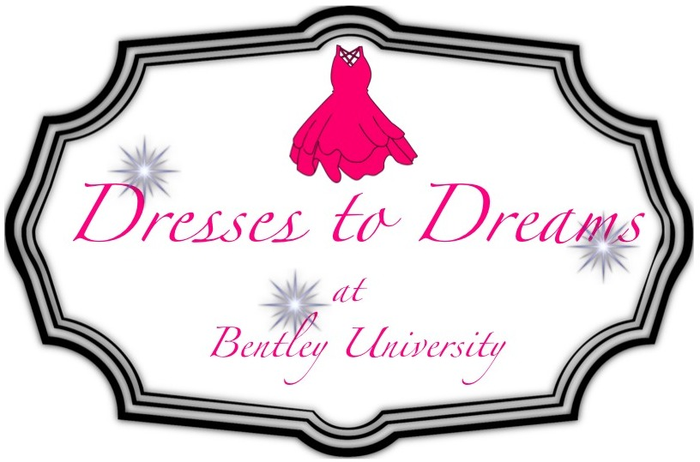

Dresses to Dreams is an organization dedicated to empowering young women to follow their dreams, building their self-esteem and giving them a free prom dress while doing so. Our event serves high school-aged young women from the Greater Boston area. The workshops at our five-hour event on the Bentley University campus include discussions regarding women’s empowerment and the importance of self-esteem, college and career-centered activities, and prom hair and beauty tutorials. The event is run and organized completely by students, who gather speakers and collect donations of prom dresses, accessories such as jewelry and shoes, food to feed about 200 young girls breakfast and lunch, and raffle items. Without our on-campus sponsor, The Center for Women and Business, and all of our supporters, this incredible day would not be possible!

*Supporter Levels*

**Bronze ($50):** At this support level, you will receive a mention on all of our social media platforms. The platforms that we use are Facebook, Twitter, Instagram, Pinterest, LinkedIn, and our website.

**Silver ($100):** At this support level, you will receive a mention across our social media, and your logo will be displayed in our scrolling presentation at the event.

**Gold ($200):** At this support level, you will receive a mention on our social media, your logo will be displayed in our scrolling presentation at the event, and you will also be able to have a table at our event. (Space is limited so register now!)

We thank you for your interest in supporting our event and contributing to its success! If you have an questions please contact us at GA_dressestodream@bentley.edu